**Project Report on**

**Recruiting Assistance For The HR Managers - (Developer)**

**Milestone_01:** Create Salesforce org

Go to developers .salesforce.com/signup

Click on signup.

On the sign-up form, enter the following details:

1. Firstname & Lastname- lakkur Sowmya Lakshmi
2. Email:sekharlakkur@gmail.com
3. Role:Developer
4. Company:GAYATRI DEGREE COLLEGE-TIRUPATI
5. Country:India
6. Postal Code:517501
7. Username:l.sowmyalakshmimecs@gdcproject.com

**Account Activation:**

Go to the inbox of the email that you used while signing up. Click on the verify account to

activate your account. The email may take 5-10mins, as

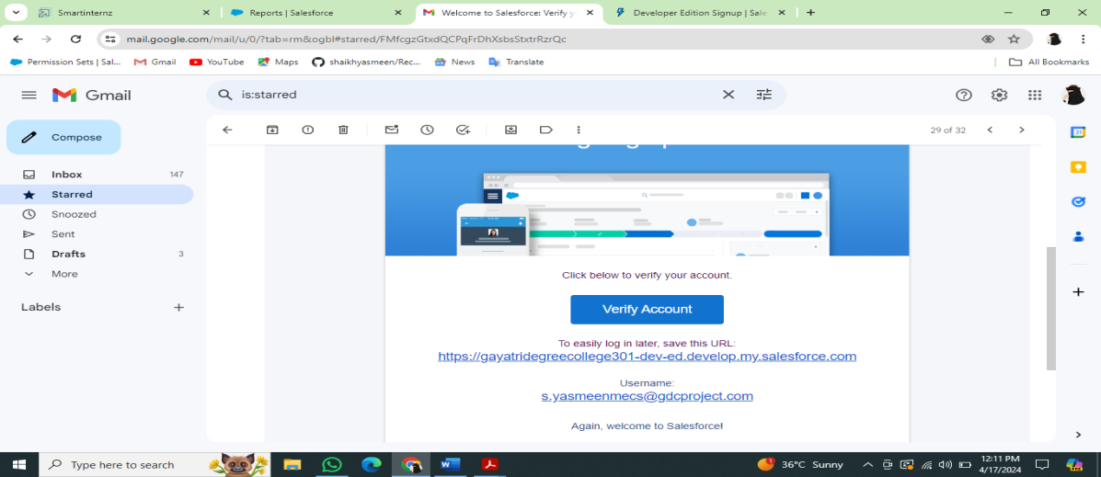

**Login to Your Salesforce Account**

1.Go to salesforce.com and click on login.

2.Enter the username and password that you just created.

3.After login this is the home page which you will see.

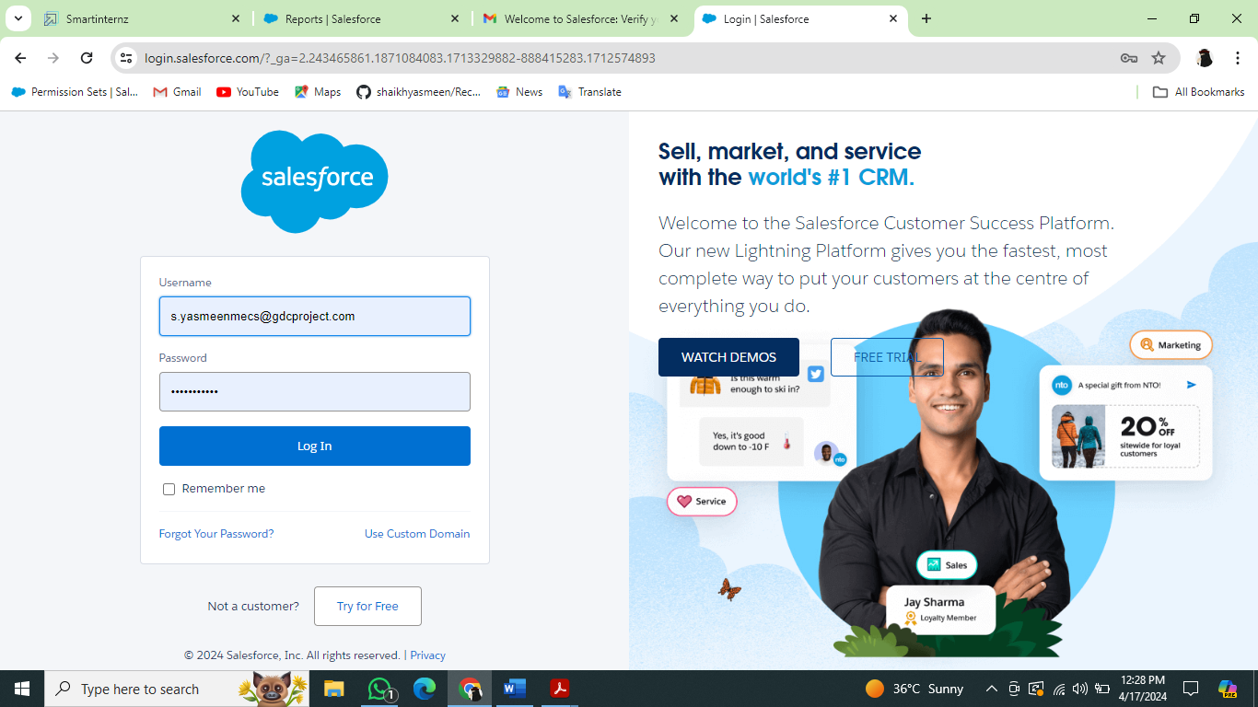

### Milestone_02:Package Installation

1.Go to the Package Installation Link.  
2. Select Install for Admins only  
3. Click install.

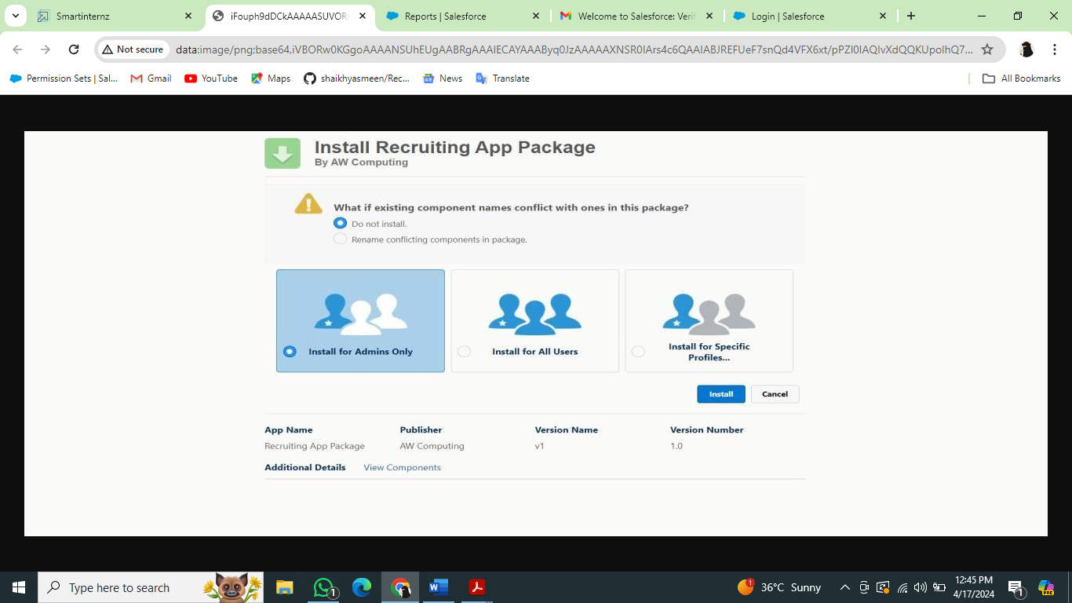

### Milestone-03: Create A Custom Object For Job Posting Sites

1. From setup click on object manager.

2.Click create, select custom object

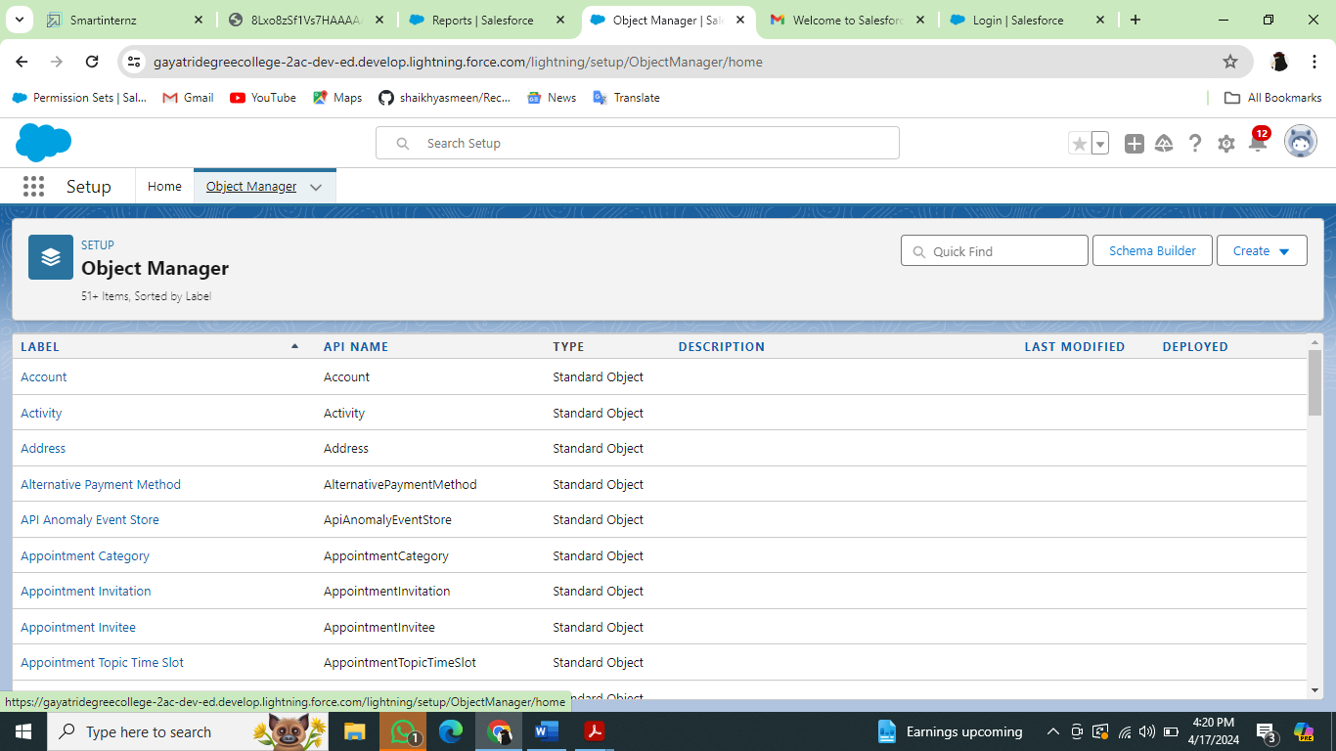

3.Fill in the label as "Job Posting Site".  
4.Fill in the plural label as "Job Posting Sites".  
5.Record name : "Site Name"  
6.Select the data type as "Text".  
7.In the Optional Features section, select Allow Reports and Track Field History.  
8.In the Deployment Status section, ensure Deployed is selected.  
9.In the Search Status section, select Allow Search.  
10.In the Object Creation Options section, select these options: Add Notes and Attachments related list to default page layout Launch New 11.Custom Tab Wizard after saving this custom object  
Leave everything else, and click and save.

### Create A Custom Object For Reviews

To create a custom object, follow these steps

From setup click on object manager.

Click create, select custom object.

1. Fill in the label as "Review".
2. Fill in the plural label as "Reviews".
3. Record name : "Review Number"
4. Select the data type as "Auto Number".
5. Under display format enter "REV-{0000}".
6. Enter the starting number as 1.
7. In the Optional Features section, select Allow Reports and Track Field History.
8. In the Deployment Status section, ensure Deployed is selected.
9. In the Search Status section, select Allow Search.
10. In the Object Creation Options section, select Add Notes and Attachments related list to default page layout.
11. Leave everything else as is, and click Save.

### Create a Junction object for Job Posting

1. T o create a custom object, follow these steps :
2. From setup click on object manager.
3. Click create, select custom object.
4. Fill in the label as "Job Posting".
5. Fill in the plural label as " Job Postings".
6. Record name : " Job posting number "
7. Select the data type as "Auto Number".
8. Under display format enter " JOBPOST-{0000}”
9. Enter the starting number as 1.
10. In the Optional Features section, select Allow Reports and Track Field History.
11. In the Deployment Status section, ensure Deployed is selected.
12. In the Search Status section, select Allow Search.
13. In the Object Creation Options section, select Add Notes and Attachments related list todefault page layout.
14. Leave everything else as is, and click Save.

### Milestone-04:Tab

**Creation Of Job Posting Sites Tab**

Now create a custom tab.

1. Click on Home tab, enter Tabs in Quick Find and select Tabs.
2. Under custom object tabs, click New.
3. .For Object, select Job Posting Sites.
4. .For Tab Style, select any icon.
5. Leave all defaults as is. Click Next, Next, and Save.

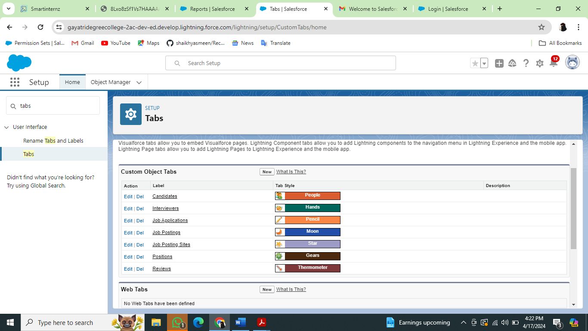

Creation Of Reviews Tab

Now create a custom tab.  
Click on Home tab, enter Tabs in Quick Find and select Tabs.

Under custom object tabs, click New.

* For Object, select Reviews.
* For Tab Style, select any icon.
* Leave all defaults as is. Click Next, Next, and Save.

Creation Of Job Postings Tab

Now create a custom tab.

* Click on Home tab, enter Tabs in Quick Find and select Tabs.
* Under custom object tabs, click New.
* For Object, select Job Postings.
* For Tab Style, select any icon.
* Leave all defaults as is. Click Next, Next, and Save.

### Milestone-05: Lightning App

Adding Job Posting Sites Tab

1.click **C:\Users\DELL\AppData\Local\Microsoft\Windows\INetCache\Content.MSO\D5810A7E.tmp**   to launch the App Launcher, then click Recruiting and follow the steps  
2. Click the pencil icon at the top right of the screen.

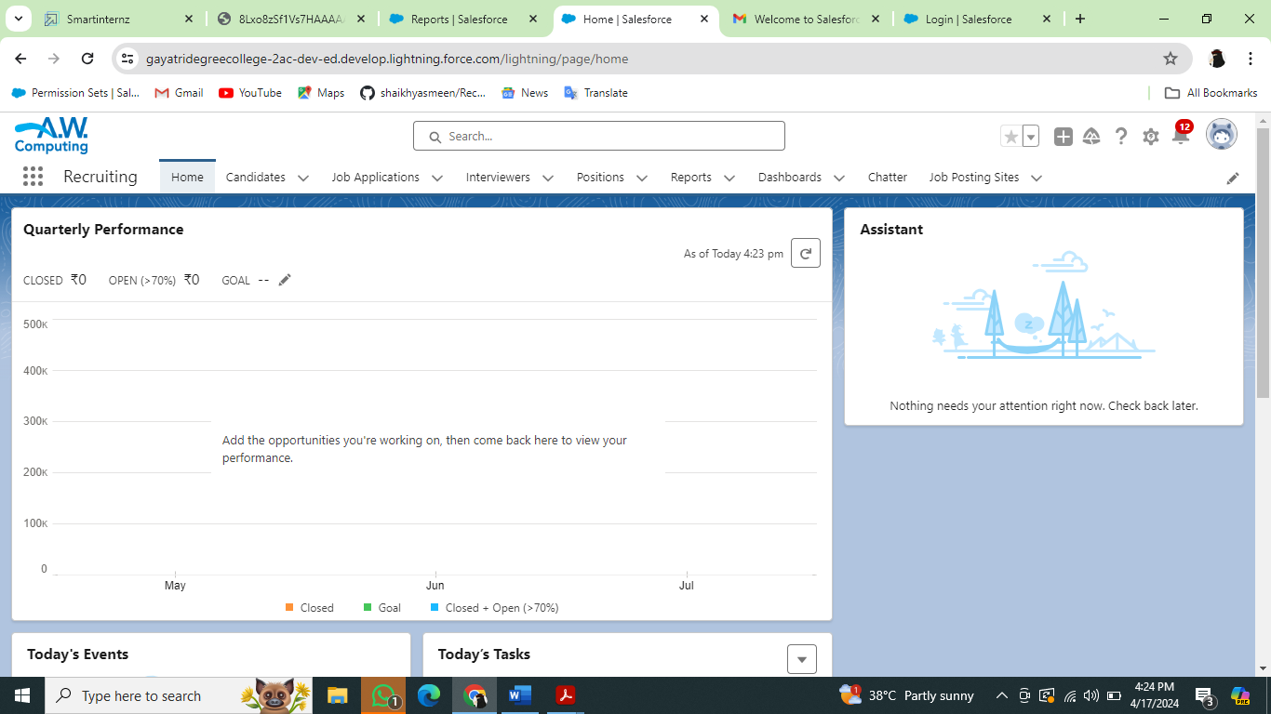

3.Click Add more Items.

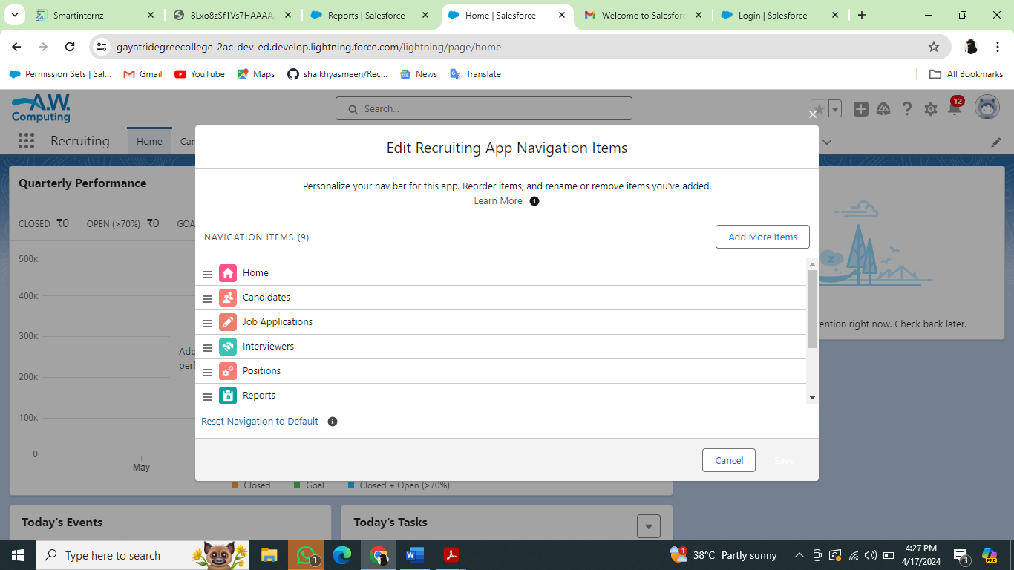4.From the menu on the left, click All.  
5.Next to Job Posting Sites, click the +.6.Click Add 1 Nav item.  
7.Click Save.

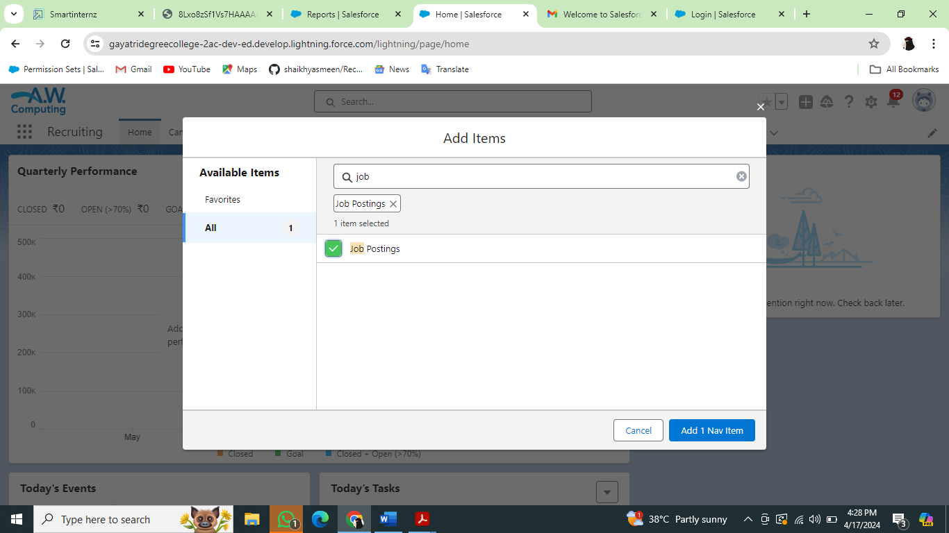

### Milestone-06: Fields And Relationships

Create New Field For Job Posting Site  
  
1.Click the gear icon and select Setup. This launches Setup in a new tab2.Click the Object Manager tab next to Home.  
3.Select job posting site.  
4.Click Field & Relationship than click new.  
5.Select the data type as URL.  
6.Click Next.  
7.For Field Label, enter the Job Posting Site URL.

8.Click Next, Next, and click Save & New.

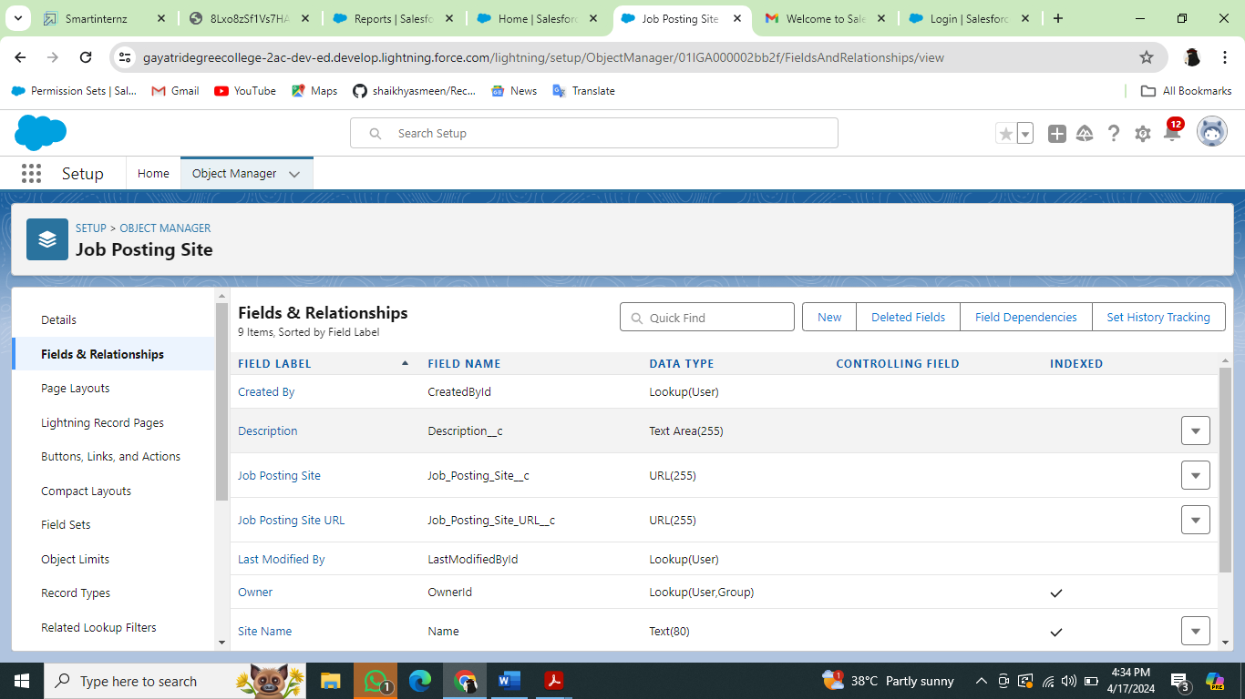

Now let's create the other fields and we must choose the data types of the fields carefully

1.Select Pick list as the Data Type and click Next. For Field Label enter Status.

2.Select Enter values, with each value separated by a new line and enter these values:

* Active
* Inactive

3. Click Next, Next, then Save & New

4. Select the Checkbox as the Data Type, then click Next. For Field Label, enter Technical Site.  
5. Click Next, Next, then Save & New.  
6. Select the Text Area as the Data Type, then click Next. For Field Label, enter Description  
7. Click Next, Next, then Save & New.

**Create pick list field for Job Posting Site object**

* Click on the gear icon and then select Setup.
* Click on the object manager tab just beside the home tab.
* After the above steps, Select Job Posting Site Object
* Now Select Fields and relationships from setup menu of the Attendee object.
* Click new and select Pick list fields ????next and enter label name(Status) and select enter values option(Active, Inactive),next, next and Save.

Create Relationships For Job Posting

Creating a master-detail relationship between Job posting and job posting site.  
1. From Setup, go to Object Manager  
2. Select job posting and click Fields & Relationships.  
3. Click New.

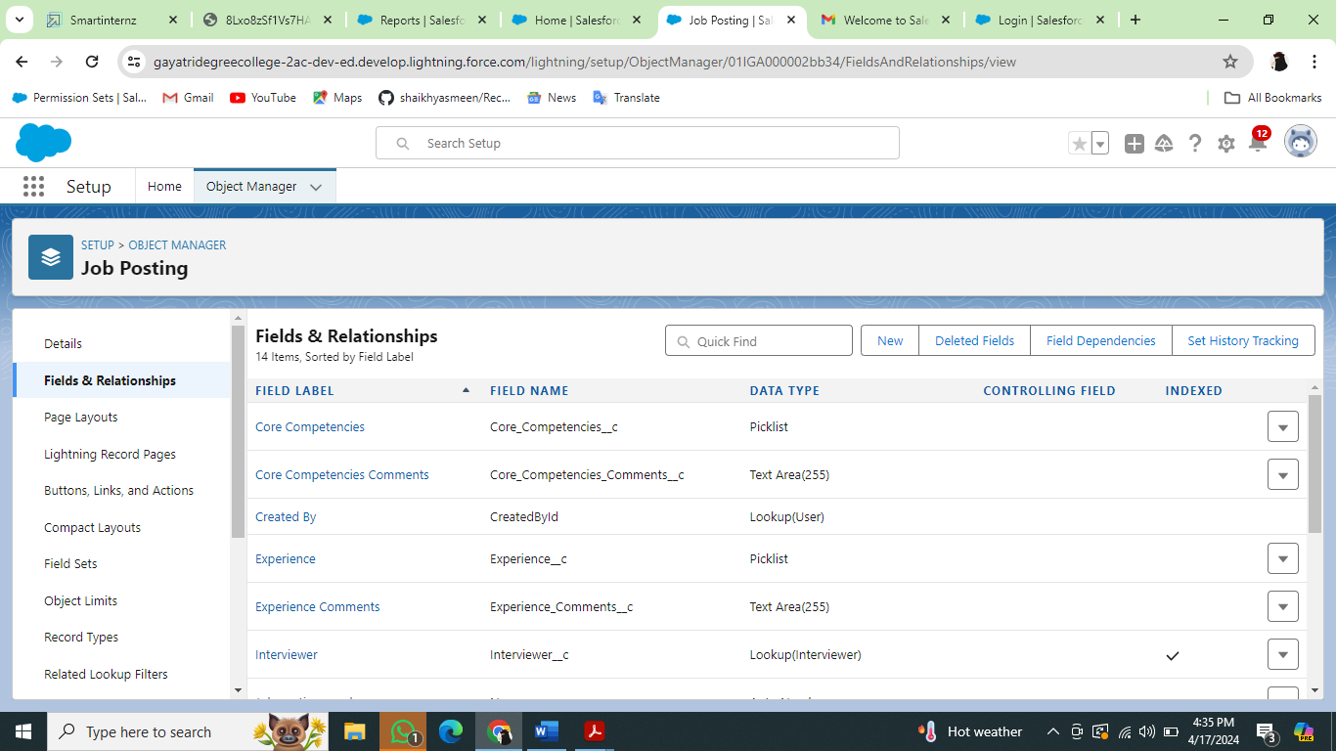

4. Choose Master-detail Relationship and click Next5. Choose the related object (Job Posting Site) and select that object.6. Enter the label name(Job Posting Site) for the lookup field

7. Click Next, Next, and Save

Creating a master-detail relationship between job posting and position for job posting object.

1. From setup, click object manager.
2. Select Job posting object, click on field and relationships, click new.
3. Select the data type as Master-detail relationship.
4. Click Next, relate to position.
5. Enter the label Position.
6. Click next, next, next and save.

### Create New Field For Reviews

Select Picklist as the Data Type and click Next. For Field Label enter Core Competencies.  
Select Enter values, with each value separated by a new line and enter these values:

1

2

3

4

5  
 For Help Text, enter “For this category, rate candidate on a scale of 1 (lowest) to 5 (highest)” Click Next, Next, then Save & New. Follow above steps and create two more pick list with Leadership Skills and  
Experience as the field labels and values same above.

2. Select the Text Area as the Data Type, then click Next. For Field Label, enter Core Competencies Comments.

Click Next, Next, then Save & New.

Follow above steps and create two more text areas with Leadership Skills Comments and

Experience Comments as the field labels.

3. Select Checkbox as the Data Type and click Next. For Field Label, enter Recommend for Hire.

For Help Text, enter “Do you recommend that we hire this candidate? “ Click Next, Next, then Save & New.

4. Select the Text Area as the Data Type and click Next. For Field Label, enter Reason Recommended.

Click Next, Next, then Save & New.

5. Create a lookup relationship field for Interviewer.

Select Lookup Relationship as the Data Type and click Next. For Related To, select Interviewer and click Next.

For Field Label, enter Interviewer. And Click Next, Next, Next, then Save & New.

6. Create a master-detail relationship field for Job Application. Select Master-Detail Relationship as the Data Type and click Next. For Related to, select Job Application and Click Next.

For Field Label, enter Job Application. Click Next, Next, Next and Save.

### Milestone-07:Page Layout

Modifying The Page Layouts

1. From setup, click on object manager.

2. Click position, then page layouts.

3. Click down array next to the position layout and select edit.

4. Scroll down to the job posting related list, and click the wrench icon in the header to edit it.

5. From the available fields section, select

Job posting site : Status

Job posting site : Technical Site

6. Click add.

7. From the selected fields section, select job posting : Job posting number and click remove

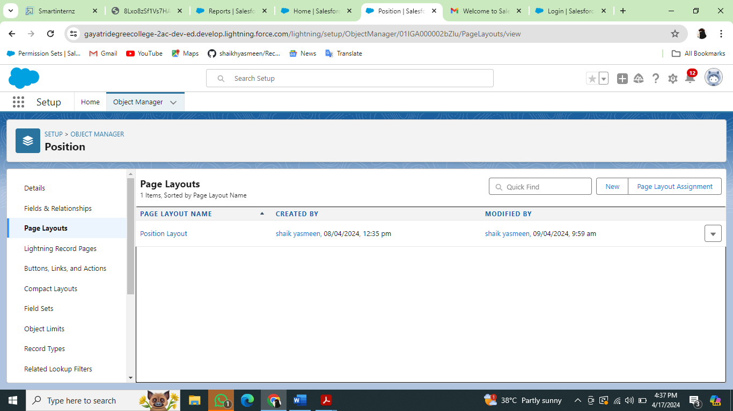

1. Click ok, then save.

Page Layout**:**Create A Page Layout For Review Object

Create a Page layout for Review Object

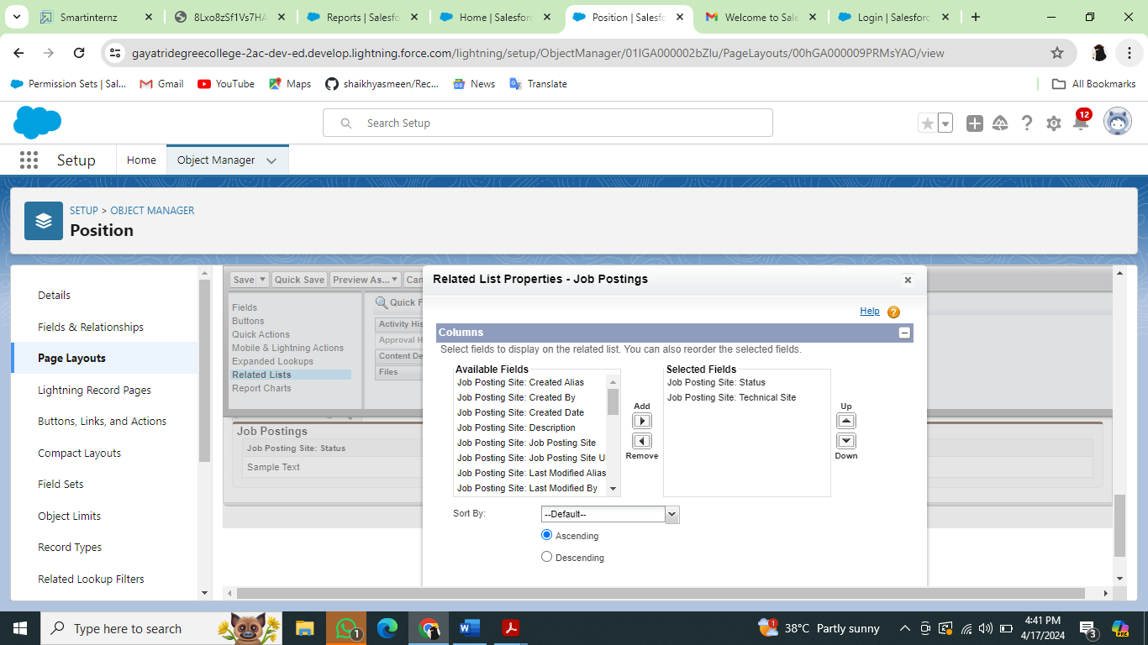

### Milestone-08:Validations Rules

### Creating A Validation Rule

To create a validation rule:

Go to object manager, select the object Candidate, scrolldown and click validation rule, New.

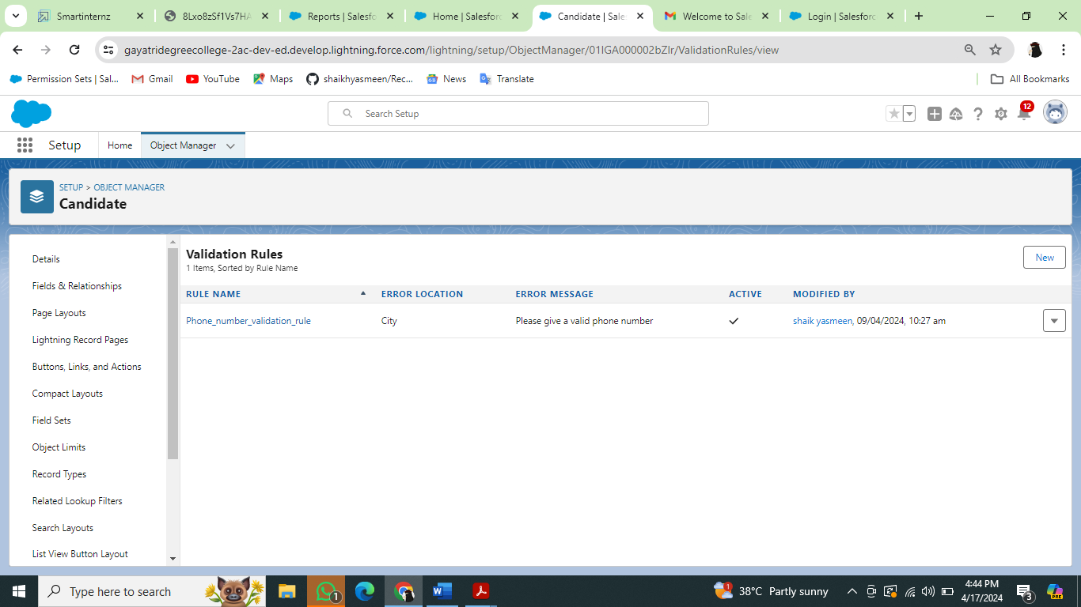

Give details as:

1. Rule name: Phone number validation rule.
2. Active: checked
3. Description: phone number should not be more than or less than 10 digits.
4. Under Error ConditGEXion Formula: write the condition using insert field, insert operator, insert function NOT(OR(RE (Phone  c, "^[0-9]{10}")))
5. Using check syntax: check if the formula you entered is valid or not.
6. Error Message: Please give a valid phone number
7. Error location: select field
8. Save

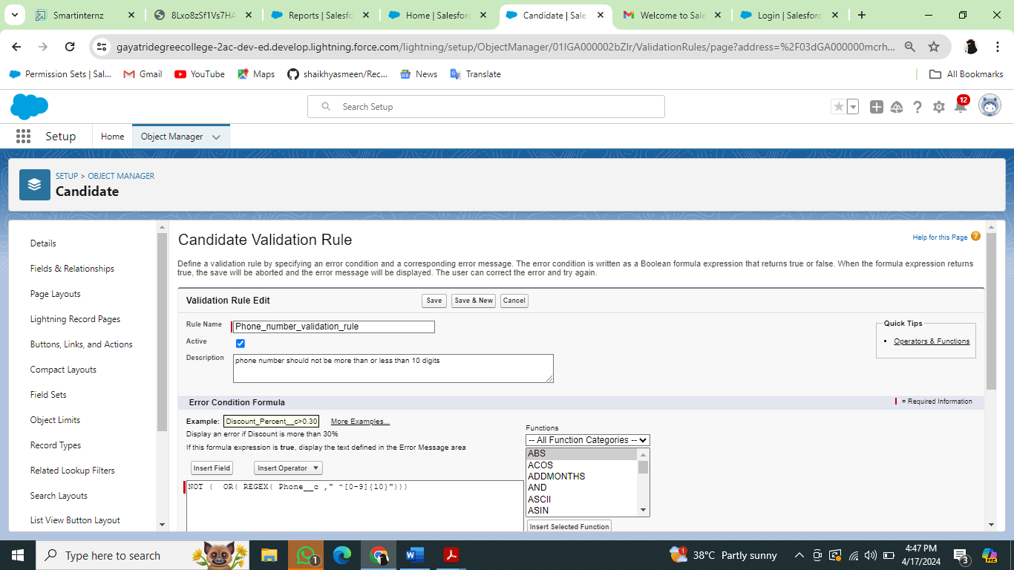

### Create A Validation Rule For Technical Site Checkbox Is Equal To True.

Go to object manager, select the object Job posting site, scrolldown and click validation rule, New. Give details as:

1. Rule name: Technical site checkbox true.
2. Active: checked
3. Description: Technical site checkbox should be check.
4. Under Error Condition Formula: write the condition using insert field, insert operator, insert function Technical_Sitec != TRUE
5. Using check syntax: check if the formula you entered is valid or not.
6. Error Message: Please select check box of technical site.
7. Error location: select field (Technical site).
8. Save.

### Milestone-09:Profile

Creation On Profile

From Setup enter Profiles in the Quick Find box, and select Profiles.

1. From the list of profiles, find Standard User

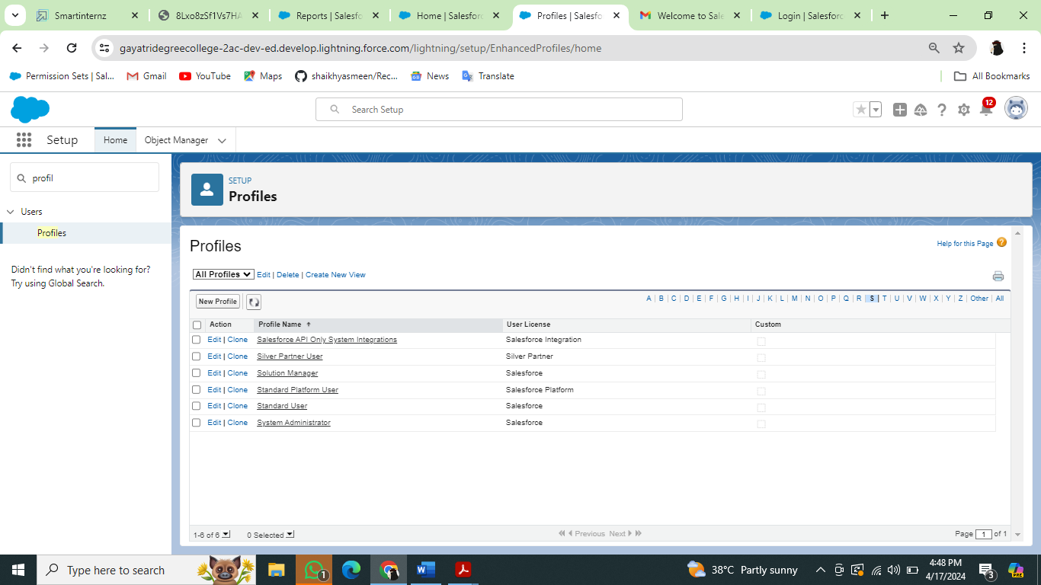

2. Click Clone.

3. For Profile Name, enter Event user profile.

4. Click Save

5. While still on the Event profile page, then click Edit

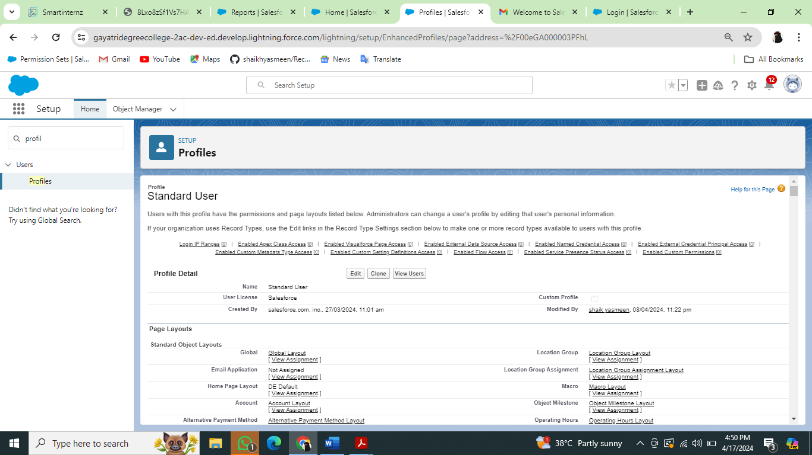

6. Scroll down to Custom Object Permissions and Give view all access permissions to the

Order details, supplier, product, customer, category, payment

Create A Profile With The Profile Name As “HR Profile”

Create a profile with the profile name as “HR Profile”. and give view all permission for interviewer ,position, job application, candidate objects.

### Milestone-10:User

**Creating A User**

From setup type “users” in quick find and select users, then click New User

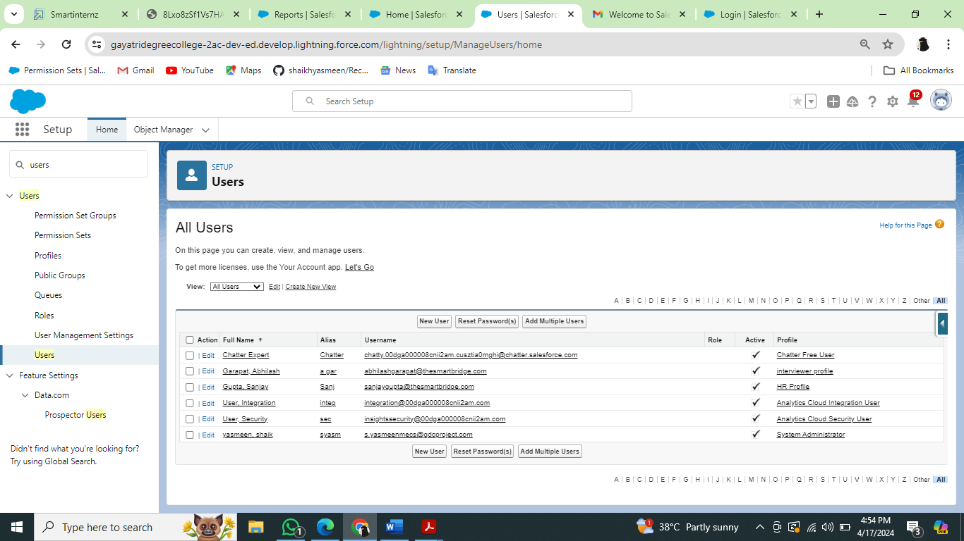

* First Name: Sanjay
* Last Name: Gupta
* Alias: Sanj
* Email: provide your personal email id for future reference
* Username: [sanjaygupta@thesmartbridge.com](mailto:sanjaygupta@thesmartbridge.com)
* Nickname: Sanju
* Role: leave it as default
* User License: Salesforce
* Profile: HrProfilie

Create Another User

Create a user with a username as “Abhilash Garapati”, and assign him the interviewer profile

### Milestone-11:Permission Set

Creating A Permission Set

1. From setup search “permission sets” in quick find and select permission set then click on New

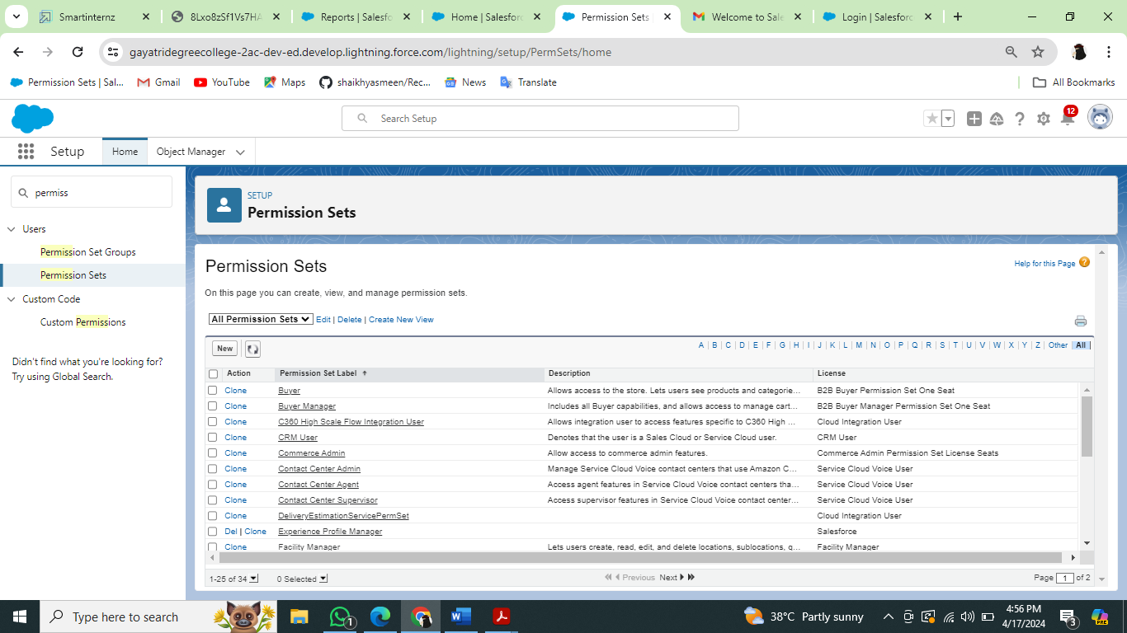

1. Enter label as: Hr Recruiter and Save.

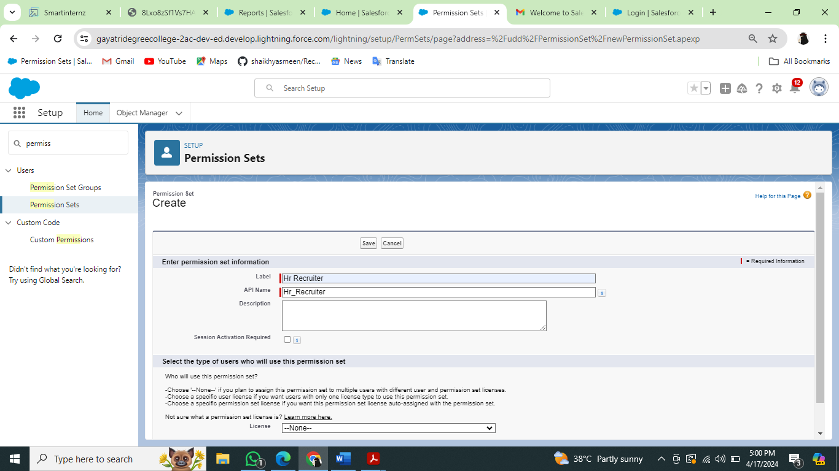

### Milestone-12:User Adoption

Create A Record (Positions)

* Click on App Launcher on left side of screen.
* Search Recruiting & click on it.
* Click on Positions Tab.
* Click new and fill details & Save.

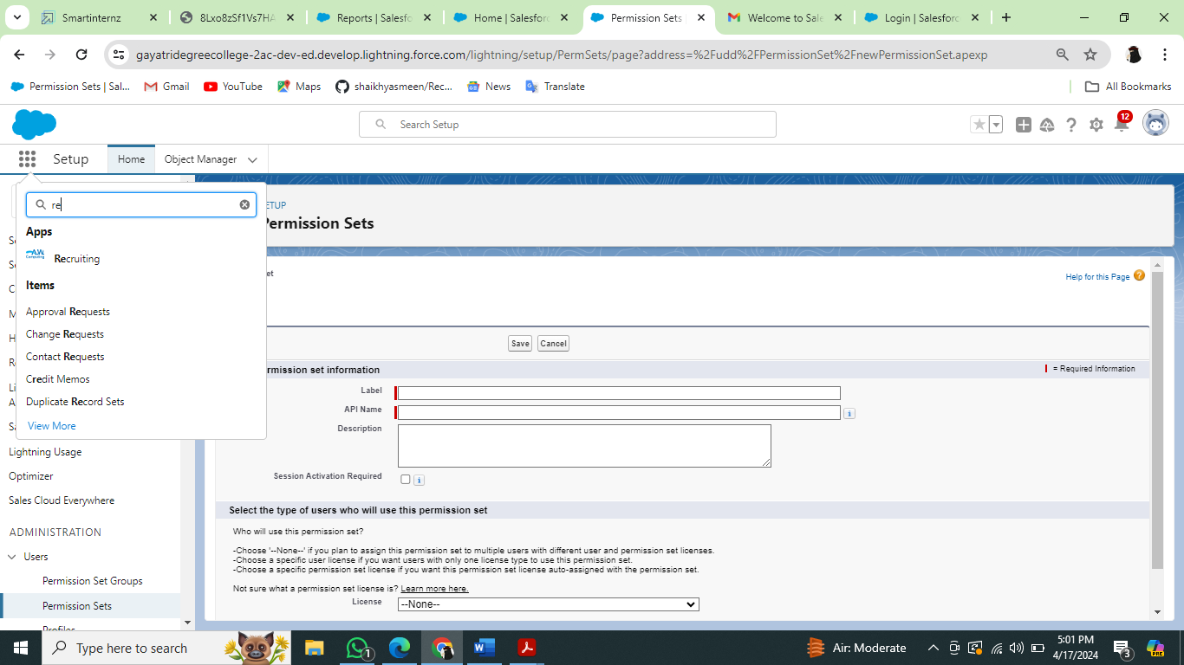

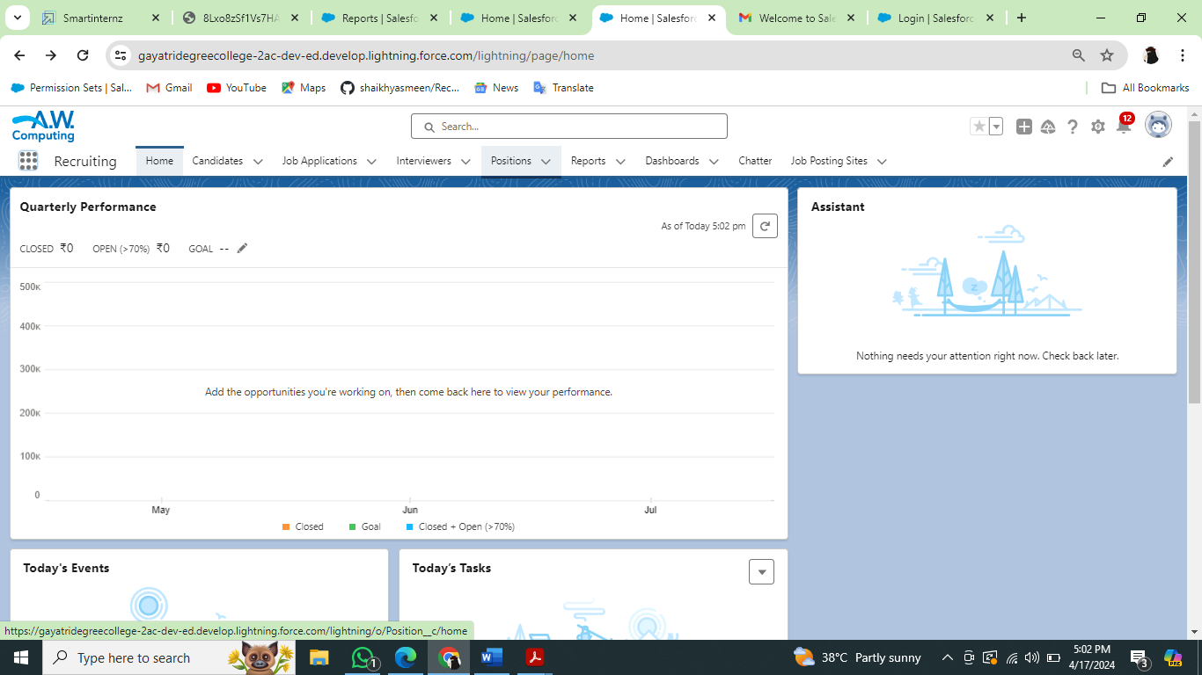

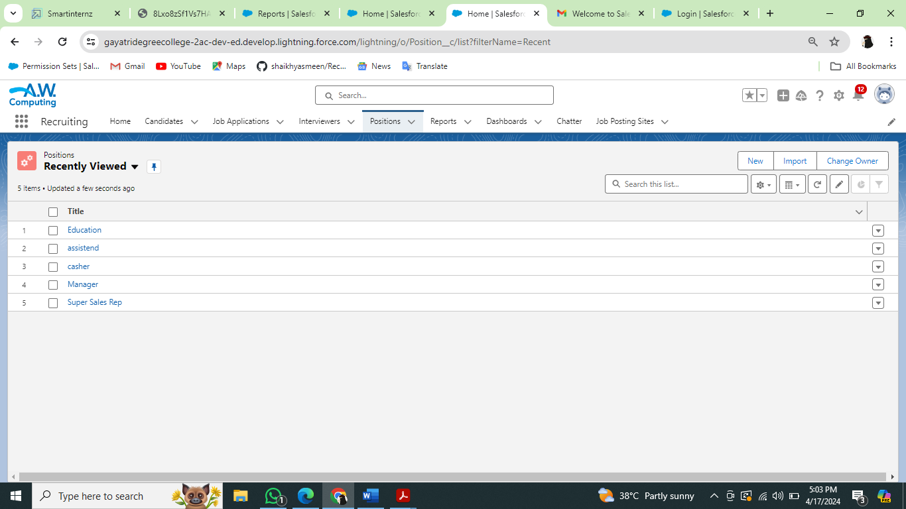

### View A Record(Positions)

* Click on App Launcher on left side of screen.
* Search Recruiting & click on it.
* Click on Positions Tab.
* Click on any record name. you can see the details of the Positions

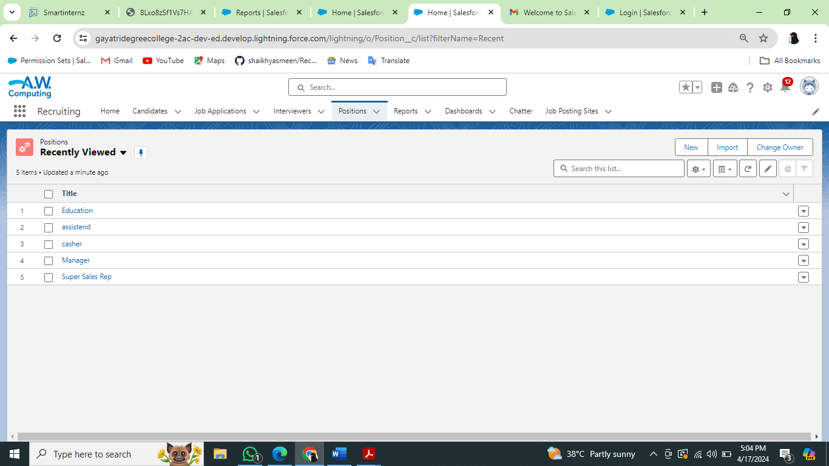

### Delete A Record (Positions)

* Click on App Launcher on left side of screen.
* Search Recruiting & click on it.
* Click on Positions Tab.
* Click on Arrow at right hand side on that Particular record.
* Click delete and delete again.

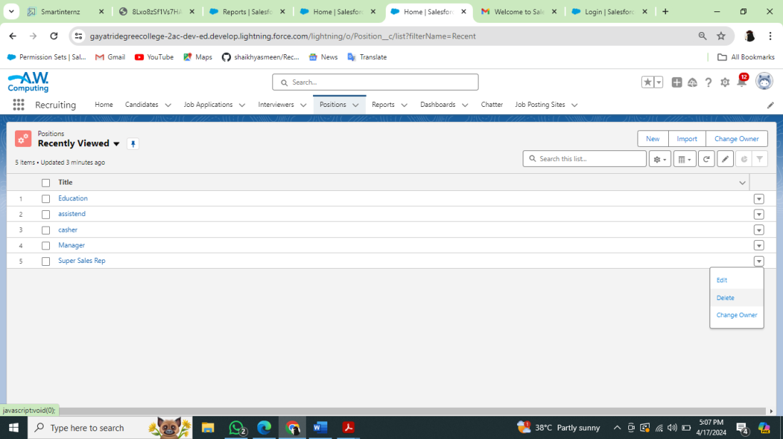

### Milestone-13:Reports

Creating A Report

1.From the Reports tab, click New Report.

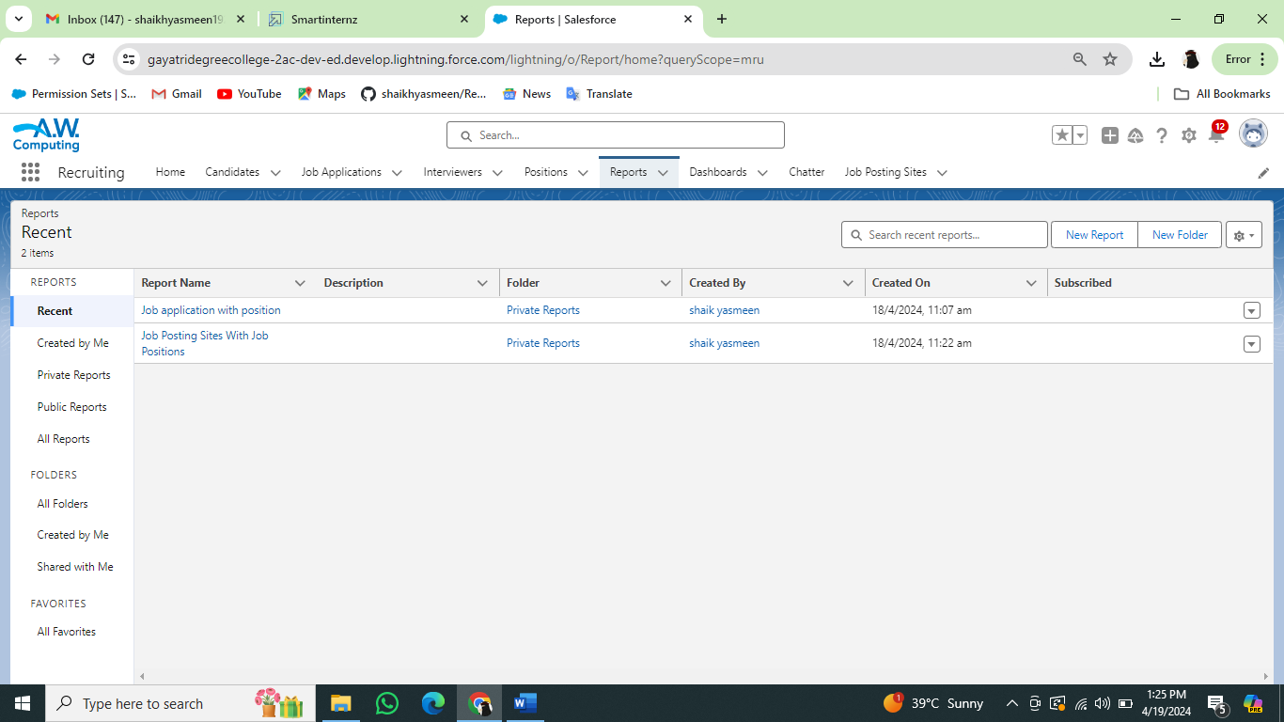

2.Select the report type Job application with position for the report, and click Create.

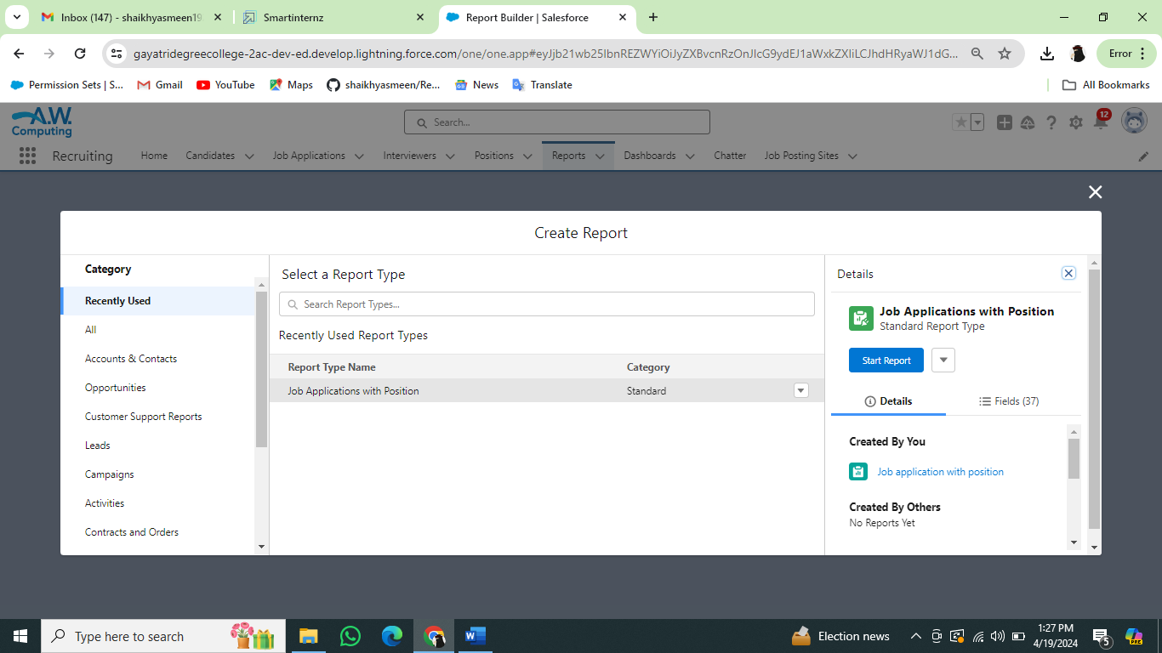

3.Customize your report accordingly and include all fields,  
Reports needs to be Grouped by one field.(ex - Created by )(require to enable add chartThen save (Job application with position) or

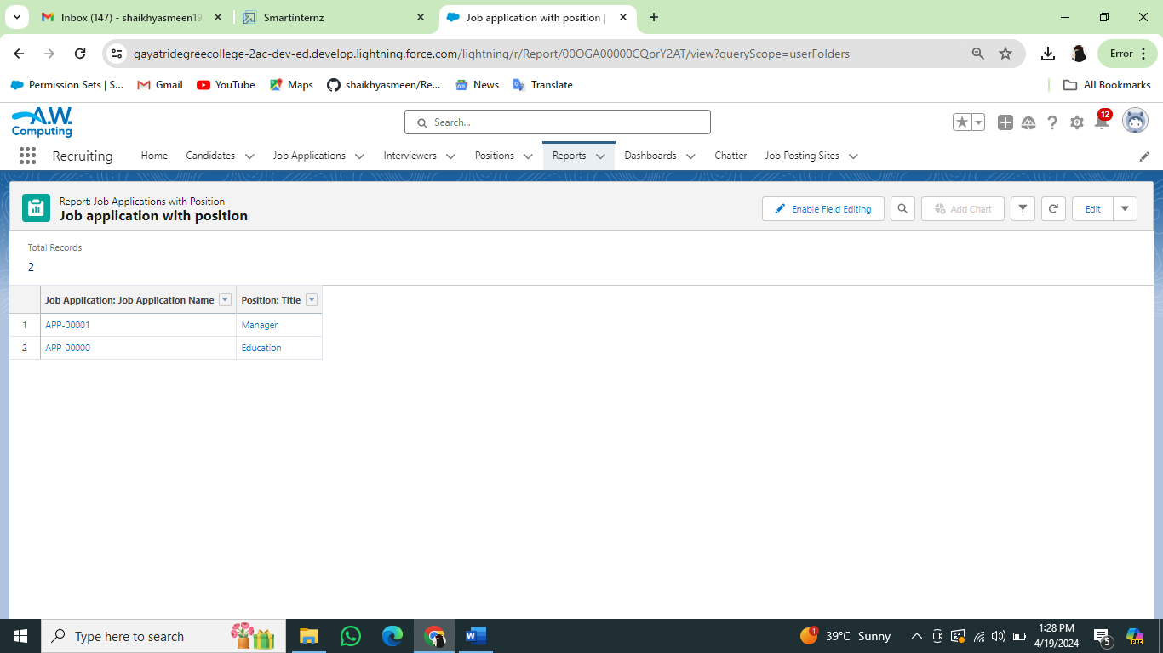

### Create A Report For Job Posting Sites With Job Positions And Positions.

### 

### 

### Milestone_14 Dashboard

Create A Dashboard

1. Click the Dashboards tab.
2. Click New Dashboard.
3. Name the dashboard Job application with position and click Create.
4. Click +Component.
5. Select Job application with position and click Select.
6. Select the Vertical Bar Chart component and click Add.
7. Click Save and then Done.

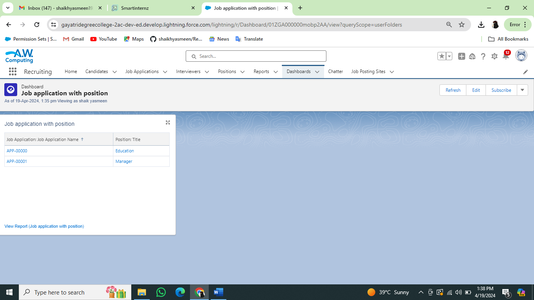

### Milestone_15 View Report And Dashboard

Report

* Click on App Launcher on left side of screen.
* Search Recruiting & click on it.
* Click on Reports Tab.
* Click on Job application with position & see record

### 

### Dashboard

* Click on App Launcher on left side of screen.
* Search Recruiting & click on it.
* Click on Dashboard Tab.
* Click on Job application with position & see records

### 

### Milestone_16 Apex Triggers

Creation Of The Trigger

**Use Case:**  
HR is struggling!! Not knowing whom to hire on priority so she contacted the developer. Now the developer made the HR task bit easy with this chages . There is the Review__c Object and there is 2 field priority and Recommended for Hire(CheckBox) so condition is like if suppose if we checked the checkbox than priority should be high  
  
**Code lines**

trigger PriorityTrig on Review__c (before insert) {

    List<Review__c> myList = trigger.new;

    for(Review__c rv:myList){

        if( rv.Recommednd_For_Hire__c == true){

            rv.Priority__c= 'high';

            system.debug(rv);

        }

        }

        }

        }

### 

### Milestone_17: DML Operations And Batchable

Create The DML Insert For The Job Posting Site

he HR Manager was looking in the Application and just checking how many candidates have applied for the job and he came to know that there are too many Candidates who applied for the job. So what the HR manager is Doing whenever there are too many Records he stores the information in the Excel sheet as per the month's Records. So he went to the Developer and asked to fetch the Record of the Job Posting Site. So This Task will be Executed with  Apex Batch

**Benefits**:

If suppose Records are getting failed after fetching the 100 Records, so we must try again to execute the Batch Method so it wont start with the starting 100 records it start fetching the records from 101 as batch runs Asynchronously.

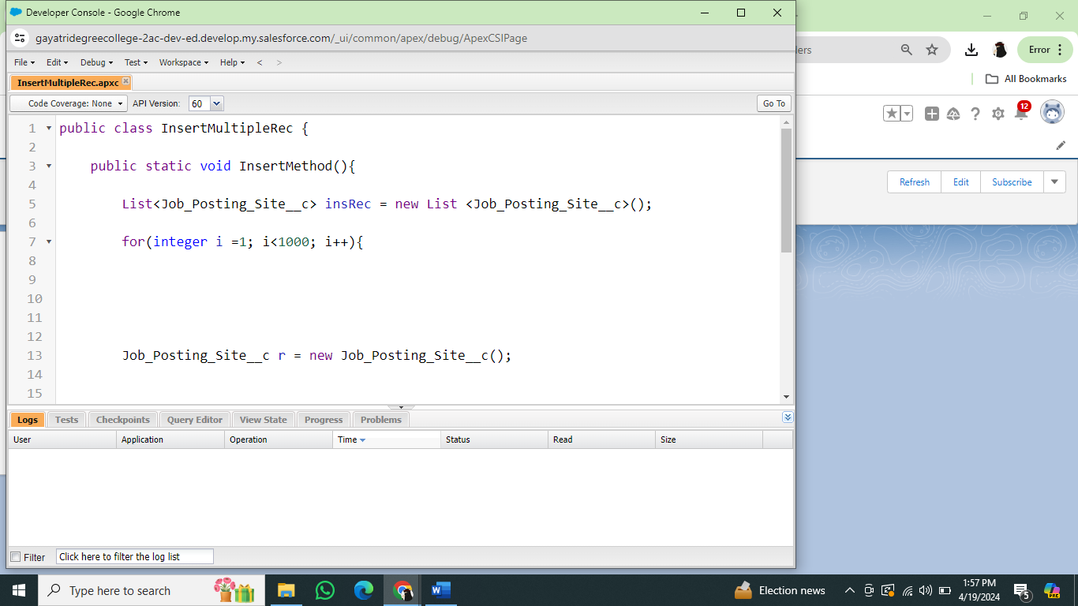

### Create The Batch

### Create the Batch Apex

public class Util1 implements Database.Batchable<sObject> {

    public Database.QueryLocator start(Database.BatchableContext bc) {

        string myList = 'SELECT Id, Name, Technical_Site__c FROM Job_Posting_Site__c';

        return Database.getQueryLocator(myList);

        system.debug('start method');

    }

    public void execute(Database.BatchableContext bc, List<Job_Posting_Site__c> accList) {

        system.debug(accList.size());

        system.debug(accList);

    }

    public void finish(Database.BatchableContext bc) {

       system.debug('finish method');

    }

}

### 

### Check The Batch

Click on the gear icon

? click on setup

? Click on the home button and search for

? Apex Jobs than you can see the success of the chunks it run 200 batch for the total record

### 